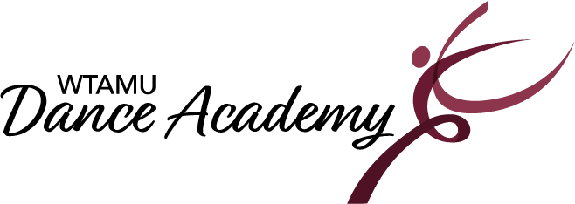
2022-2023 Important Dates

Registration Opens: August 1st- December 2nd
Classes Begin: August 22nd
Classes End: December 2nd – Winter Break
Classes Resume: January 9th
Classes End: May 5th
Dress Rehearsal for Recital: May 6th
Recital: May 7th

Buddy Week: September 12th- 17th
Holidays:
September 5th: Labor Day
November 21st-25th: Thanksgiving Break
December 3rd- January 8th: Winter Break
January 16th: Martin Luther King Jr. Day
March 13th-17th- Spring Break
April 7th: Good Friday

